**Al-Hussein Technical University**



**Mohammad Al-Mashaikh**

**Supervised by**

**Bisharah Estiphan**

**(2022-2023)**

# Abstract

"This technical report provides an overview of a point of sale (POS) system implemented in PHP. The system was designed to streamline and automate the checkout process for Shop businesses.. Additionally, it includes inventory management ,and transaction of the stock This report will discuss the system's architecture, key components, and implementation details."

# Acknowledgment

At the beginning we would like to thank ALLAH from whom we always receive guidance and help.

We would also like to thank our families for their patience, guidance, advice. May our work make them proud of what we have accomplished at HTU

Further, we would like to express our deepest thanks and gratitude to the amazing Bisharah Estiphan for his guidance and support, and all the great suggestions he have gave us throughout the project.

# Table of Contents

Abstract i

Acknowledgment ii

Table of Contents iii

List of Figures iv

List of Tables v

1 CHAPTER ONE: INTRODUCTION 1

1.1 Background 1

1.2 Business Model 2

1.2.1 Business Needs 2

1.2.2 Business Environment 2

1.2.3 Stakeholder Analysis 2

1.2.4 System Vision Document 3

1.2.5 Project Management 3

1.2.6 Development Environment 3

2 CHAPTER TWO: REQUIREMENTS 4

2.1 Gathering Requirements 4

2.2 System Problem Statement 4

2.3 Functional, Non-Functional Requirements and System Constraints 4

3 CHAPTER THREE: DESIGN 5

3.1 Design the login 5

3.2 Software Architecture Design 5

3.3 Design the database 5

3.4 Design Dataflow diagram 5

3.5 Design Entity Relationship Model 5

3.6 Design the the system and user interface 5

Design the system security 3.7 5

4 CHAPTER FOUR: IMPLEMENTATION 6

4.1 Generate Design class model to specific programming language syntax 6

5 CHAPTER FIVE: TESTING 7

5.1 Unit Testing 7

5.1.1 Set cases test 7

5.2 Integration Testing 7

5.3 Other Testing( optional) 7

6 CONCLUSIONS AND FUTURE WORK 8

6.1 Conclusion 8

6.2 Future work 8

References 9

7Appendix 10

# CHAPTER ONE: INTRODUCTION

## 1.1 Background

A POS (point of sale) system is a software application that businesses can use to manage various aspects of their operations, such as sales, inventory, and users information. A POS system that is implemented using PHP (Hypertext Preprocessor) would be a web-based application that uses the PHP programming language to handle server-side processing and a web technology such as HTML, CSS, JavaScript(JQuery) and AJAX for the front-end user interface.

A typical web-based POS system built with PHP would use a three-tier architecture, with a presentation layer (front-end), an application layer (back-end), and a data layer (database). The presentation layer would handle user interface, Input validation, and user authentication. The application layer would handle the business logic and interact with the data layer to access and update information stored in the database. The data layer would store all the important data of the POS system like Items details, User details, Invoices and other transactions.

## 1.2 Business Model

### 

**1.2.1**  **Business Needs**

### A POS (point of sale) system is a critical tool for businesses because it helps them to manage various aspects of their operations more efficiently and effectively. Some of the main business needs that a POS system can address include:

1-Sales Management: A POS system can help businesses to keep track of their sales,

2-Inventory Management: A POS system can help businesses to manage their inventory more effectively

3-User Management: A POS system can also help businesses to manage their users information, including their information,

### 1.2.2 Business Environment

This environment includes everyone who has a shop or a products to sell .

**1.2.2.1 Software Context Diagram**

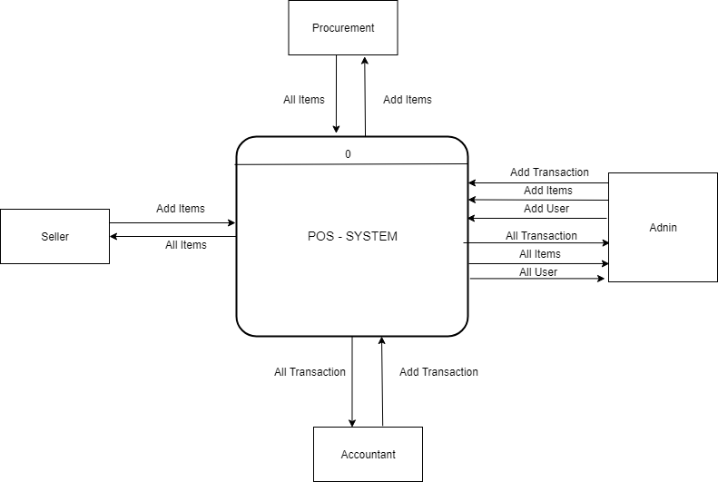

**Figure 1-1 system context diagram**

#### 1.2.2.2 System Scope

* Item management: This allows users to add, edit, and delete items that are sold through the POS system.
* User management: This allows Admins to add, edit, and delete users information, including contact details and
* Sales management: This allows users to process transactions.
* Inventory management: This allows users to track the quantities of items in stock.
* Security: This ensures that only authorized users can access the system and perform specific actions.

### 1.2.3 Stakeholder Analysis

|  |  |  |
| --- | --- | --- |
| **Stakeholder Represent** | **Role** | **Stakeholder** |
| Who can control everything in the website | Can View everything also can add, delete, edit, update everything in the website. | Admin |
| Who wants to show Items and add item | Can view only Stock and add items. | Procurement |
| Who wants to show all transactions and delete transaction | Can view only all transactions and delete transaction. | Seller |
| Who wants to show all transactions and also add, delete transaction | Can view only transactions and add transaction | Accountant |

**Table 1-1 stakeholder analysis**

### 1.2.4 System Vision Document

#### 1.2.4.1 Objectives

It help to management of our inventory

#### 1.2.4.2 Benefits

* Better Inventory Management
* Better Users Experience

#### 1.2.4.3 Capabilities

The application presents a group of items which is stores in inventory. We can create unlimited users and unlimited items so in the future maybe the capacity will increase.

### 1.2.5 Project Management

#### 1.2.5.1 Project Financial Feasibility and Risk Analysis

Feasibility study is a test of system proposed regarding its workability, impact on the   
organisation, ability to meet the needs and effective use of resources, Thus when a new

Project is proposed, it normally goes through a feasibility study before it is approved

for development. A feasibility study is made to see if the project on completion will

serve the purpose of the organisation for the amount of work, effort and the time that

is spent on it. Feasibility studies let the developer foresee the future of the project and

its usefulness. All the projects are feasible given unlimited resources and infinite time

|  |  |
| --- | --- |
| **Strength** | **Weakness** |
| 1- the design is look modern  2-our project is full secured from unknown attackers. | 1. website might face some technical issues with the project .  2.Time could be an issue . |
| **Opportunities** | **Threats** |
| 1-in the future we can grow up the website and start upload it in a server. | 1- Appearance of a competitor |

**Table ‎1-2 Project Risk SWOT**

### 1.2.6 Development Environment

#### 1.2.6.1 Development Tools and Support Services

* Visual Studio
* Xammp
* PhpMyAdmin
* Microsoft Word, Microsoft Power Point, Microsoft Teams

#### 1.2.6.2 System Development Process

* **inception** — where the project’s business case is stated and the team decides if the project is worth doing or if it is even possible. It is important to the process to first formulate the scope of the project and also determine what resources will be needed.
* **elaboration** — where the developers take a closer look at the project to determine its architecture foundation and to evaluate the architecture in relation to the project
* **construction** — where the development of the project is completed. The application design is finished and the source code is written. It is in this stage that the software is tested to determine if the project has met its goal laid out in the inception phase.
* **transition** — where any fine-tuning is performed. Any final adjustments can be based on user feedback, usability or installation issues.

**Unified Process Life Cycle Model**

We choose this model because UP Process deal with Software Engineering in flexible way and this is the steps in UP Process

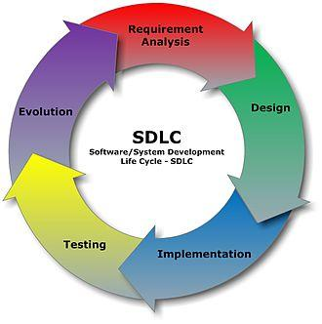

- **Business Modelling**

Understand the business environment.

1. **Requirements.**

- Gather detailed information.

- Define functional and non functional requirements.

- Develop user interface dialogs.

- Evaluate requirements with users.

2. **Design**.

- Design support services architecture and deployment environment.

- Design the software architecture.

- Design the database.

- Design the system and user interfaces.

4. **Implementation.**

- Build software components.

5. **Testing.**

-Define and conduct user acceptance testing.

# 2. CHAPTER TWO: REQUIREMENTS

## 2.1 Gathering Requirements

* **Interviews**

Stakeholder interviews are a common technique which is used in requirement analysis. We choose the interview method because it focuses on the perspectives and perceived needs of the stakeholder, often this perspective deficiency has the general advantage of obtaining a much richer understanding of the stakeholder's unique business processes, decision-relevant, business rules and perceived needs.

## 2.2 System Problem Statement

Not many problem were found , because this app is to provide the Admin all the permissions so he can control all the website.

## 2.3 Functional Requirements

|  |  |
| --- | --- |
| **Actor** | **Function** |
| Admin | 1. dashboard view 2. All items view 3. Create item 4. All users view 5. Create user 6. All transaction view 7. Create transaction 8. Edit item 9. Delete item 10. Edit user 11. Delete user 12. Delete transaction |
| Seller | * All transactions view * Delete transaction |
| Procurement | 1. All items View 2. Add items 3. Edit item 4. Delete item |
| Accountant | * All transaction View * Create Transaction * Delete Transaction |

Table 2-3 Functional Requirements

## 2.3 Non-Functional Requirements

Non - functional requirements are conditions and constraints which the program must conform , and the following list summarised non - functional quality attributes of a program

|  |  |
| --- | --- |
| **Requirement** | **How?** |
| Simple Navigation | Creating for users with different cognitive processing |
| Usability | simply easy to use app |
| Correctness | The application do what is required and do it successfully |
| performance | the system response time for every in conducted by the user must not exceed more than a minimum of 10 second |
| Reusability | Future works |
| Security | Our system is full secure to a username and hashing password by ensure the integrity of the system from accidental or malicious damage |

Table 2-4 Non-Functional Requirement

# 3. CHAPTER THREE: DESIGN

## 3.1 Design the login

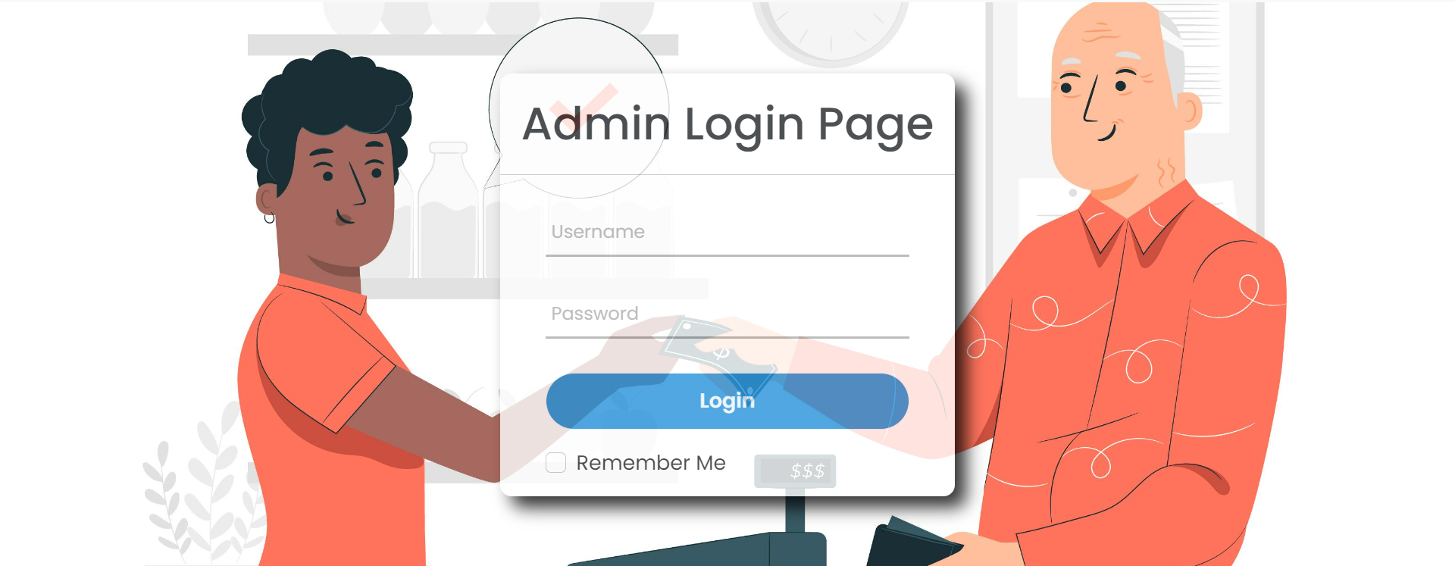

## 3.2 Software Architecture Design

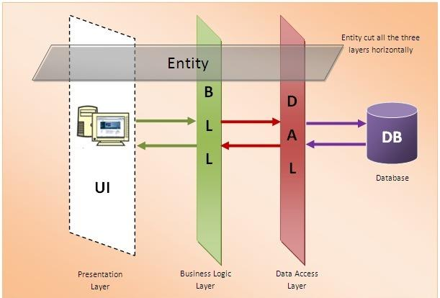

## 3.3 Design the database

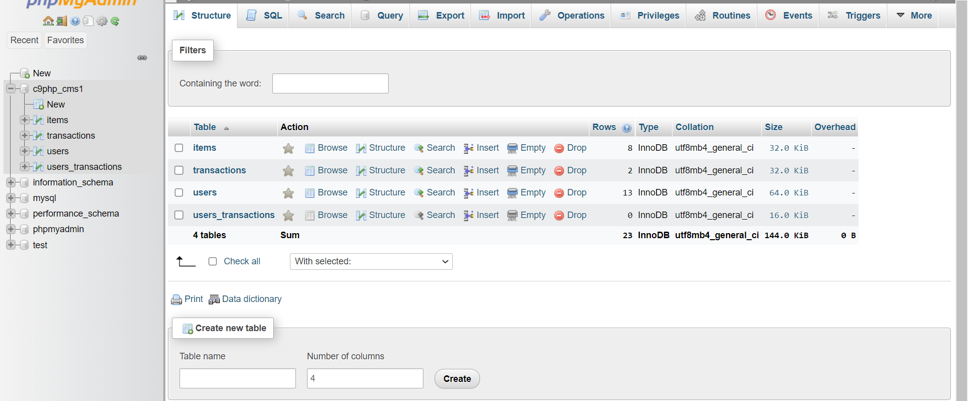

**3.4 Design Data Flow Diagram**

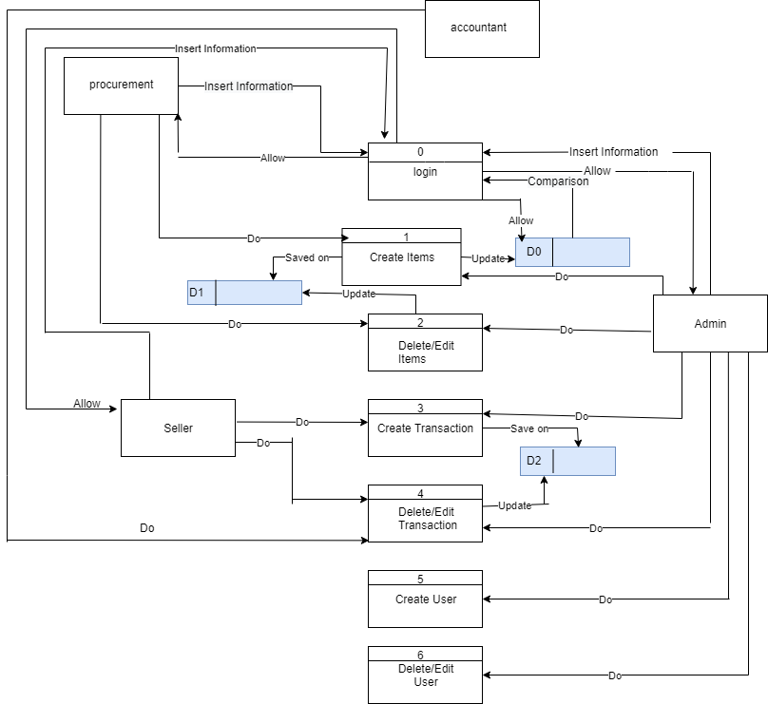

### 3.5 Design Entity-Relationship Model

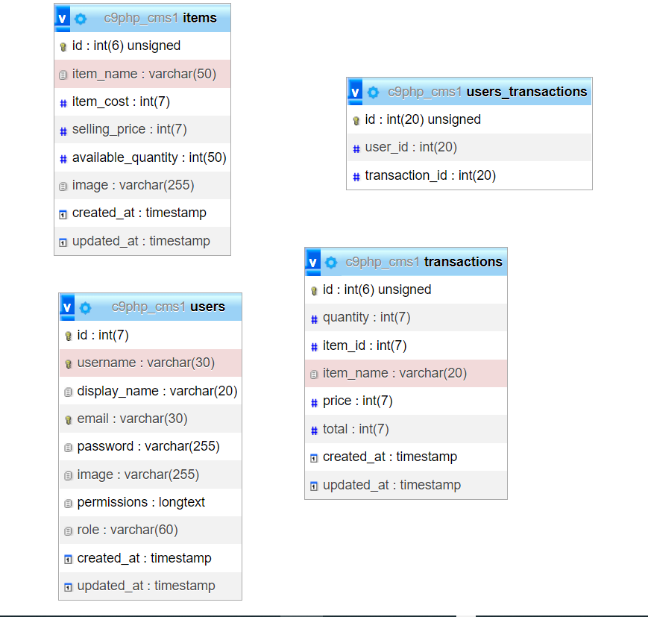

## 3.6 Design the system and user interfaces

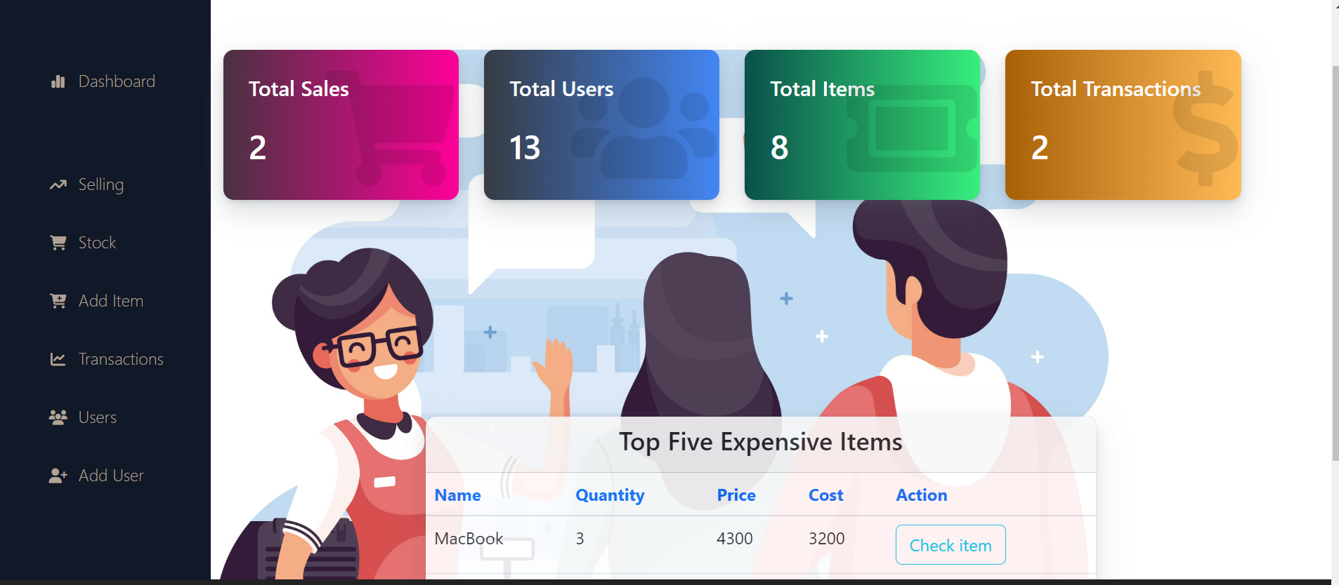

Dashboard

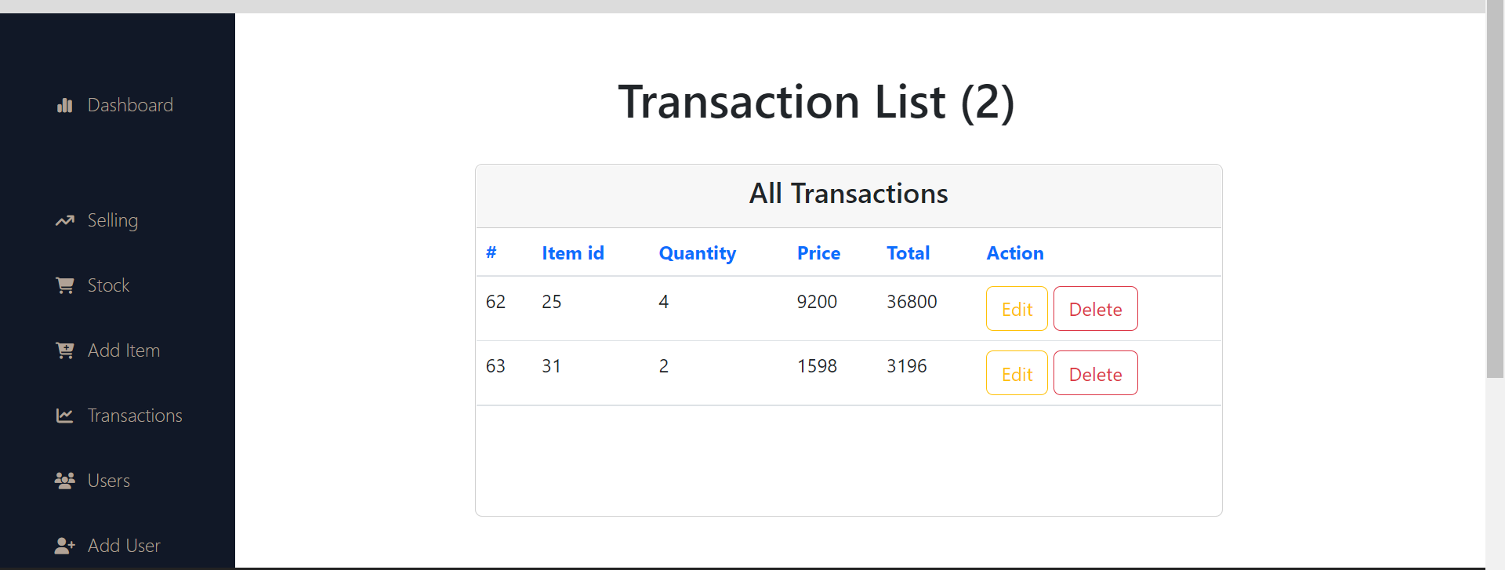

Selling

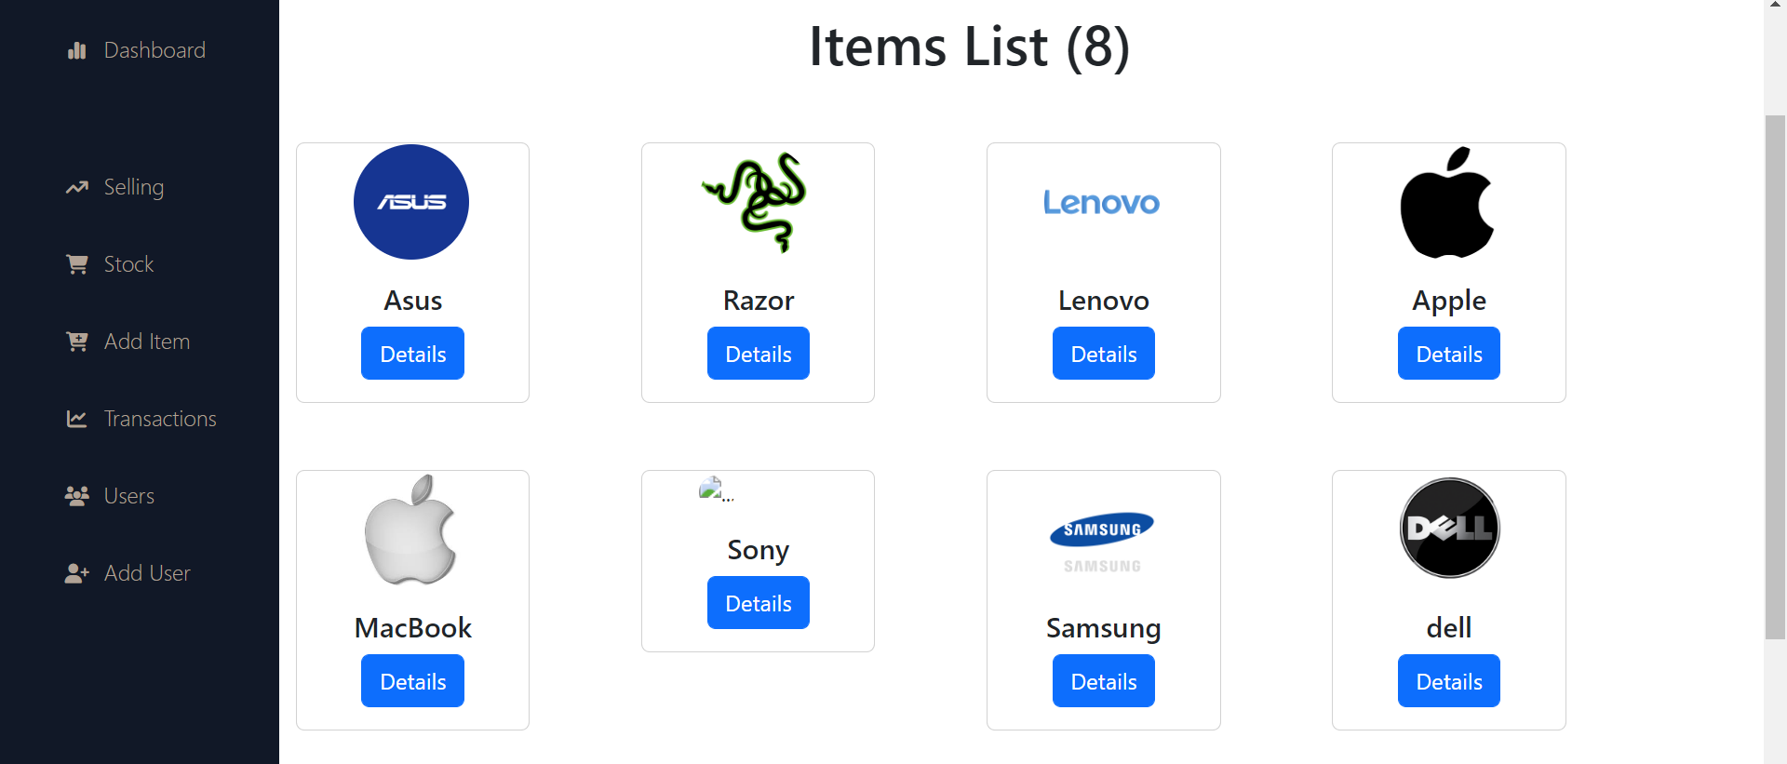

All items List

Add item

Create Transaction

All users

Create User

## 3.7 Design the system security.

Each user will have a username, password, and login security, through the admin’s supervision, the system will be safe from any modification by users, and people who are not authorised to enter the platform are not allowed

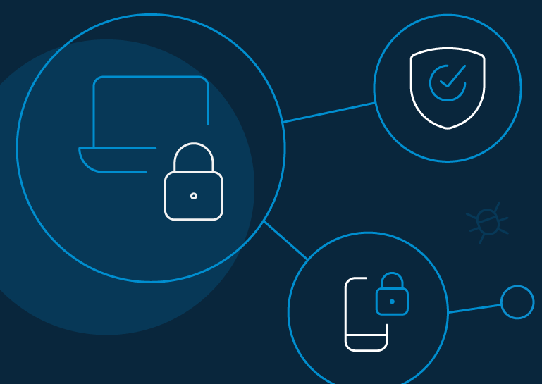

# 4. CHAPTER FOUR: IMPLEMENTATION

## 4.1 Generate Design class model to specific programming language syntax

**Login**

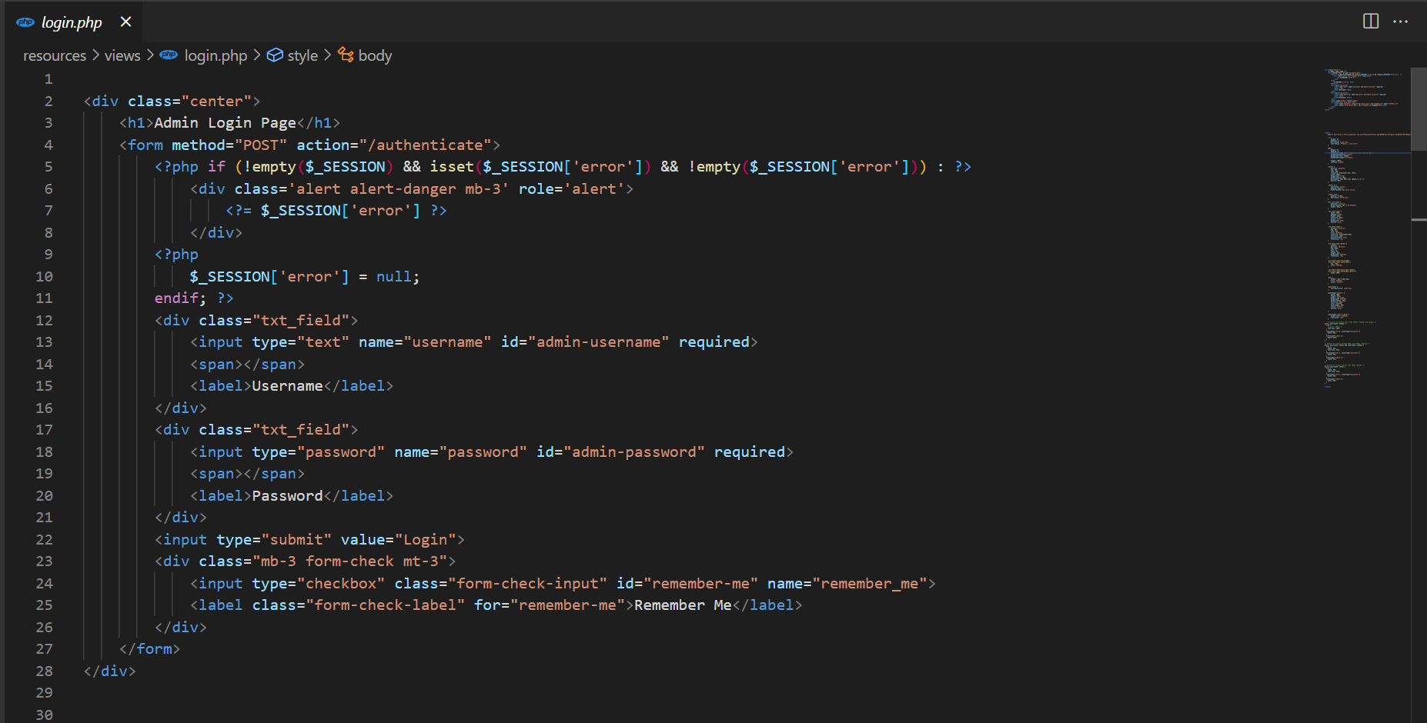

## 

## Building your code

Dashboard

User Page

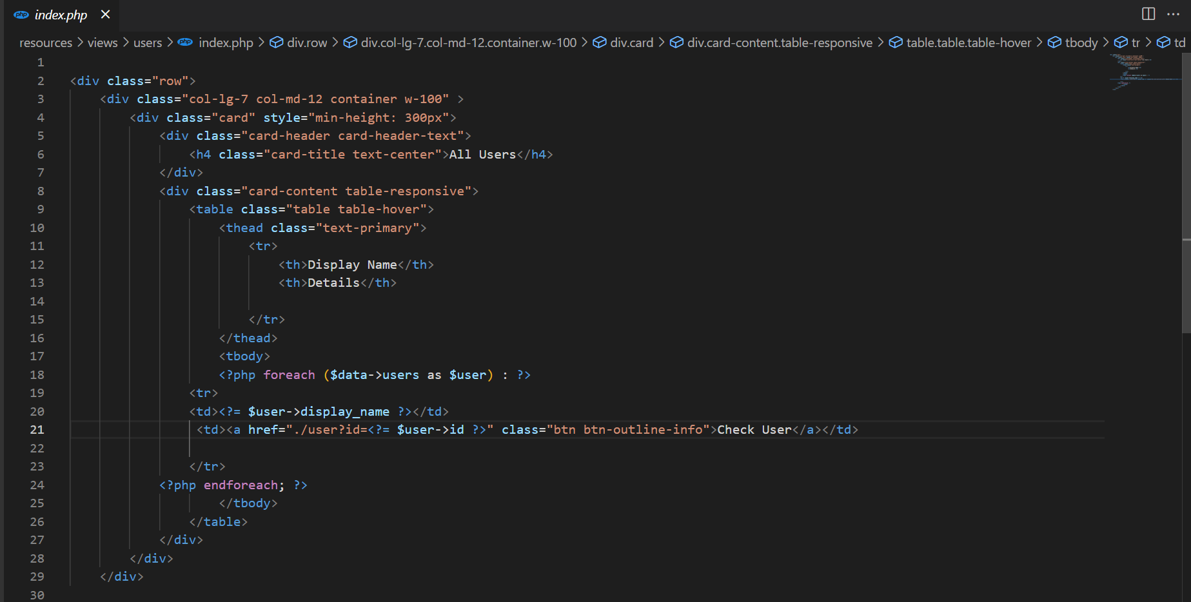

Item Page

Transaction Page

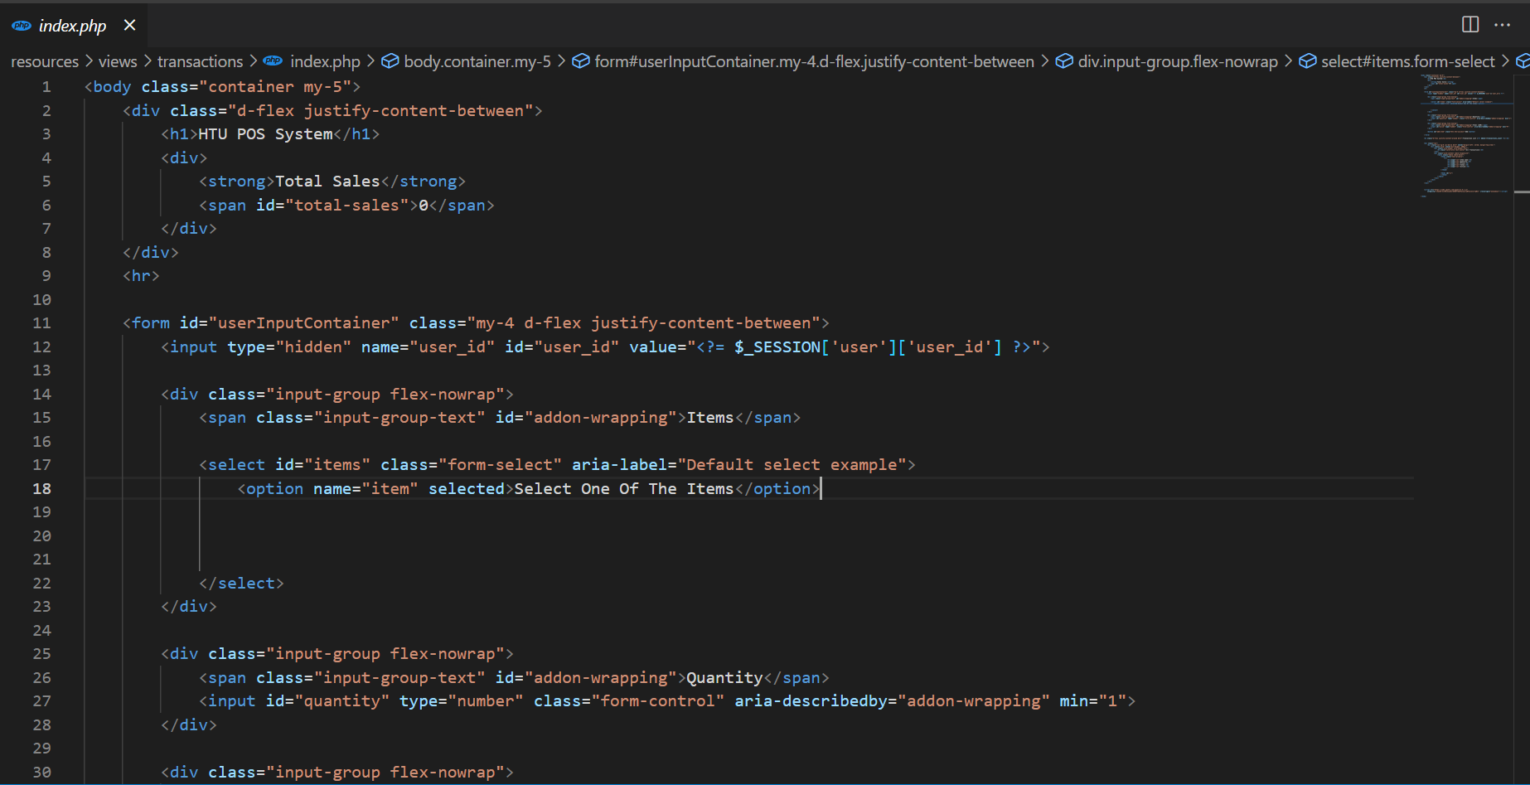

# 5. CHAPTER FIVE: TESTING

## 5.1 Unit Testing

We did the test process on system components sparely and we found some errors and exceptions were fixed , the system running smoothly with maintenance for no new future errors

### 5.1.1 Set cases test

## Test every single major function such as a login.

## 5.2 Integration Testing

The integration test that we applied on the system is aiming to make the main components of the system run in a suitable way to transfer the data in an orderly cycle . We did test for the integration between system components and fixed all constraints to make system components run together

5.3 **Functional Testing**

To check the main functions of the system and fixing the major bugs that we get , we apply the functional test , now we have release with no bugs

# 6. CONCLUSIONS AND FUTURE WORK

## 6.1 Conclusion

In conclusion, the development of a Point of Sale (POS) system is crucial for HTU's store at King Abdullah Business Park in order to effectively handle customer transactions, track sales and inventory, and provide real-time data to the administrator. The POS system will improve efficiency, accuracy, and the overall customer experience, leading to increased profits and a stronger competitive advantage for the store. The scope of the project includes the development of a web application that meets these requirements and does not include physical hardware or integration with external systems. By meeting the objectives of the project, the POS system will enable HTU to effectively manage its store and drive business success.

## 6.2 Future work

Add more items

Browse the application without the need for the Internet

View a daily topic and activate alerts Daily reminder to read

**Appendix 7.0**

In figure (20) and figure (21) shows part of code for model to call with database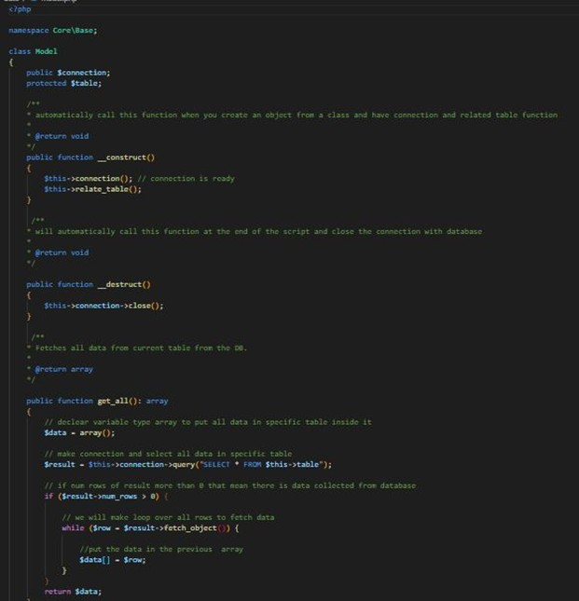

Figure (20): model code

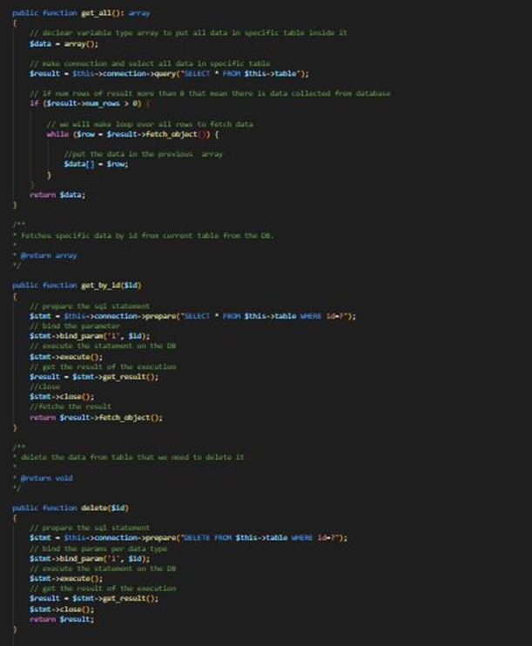

Figure (21): model code

In figure (22) shows view class that responsible for included the php html template

Figure (22): view model

In figure (23) the jQuery and ajax code.

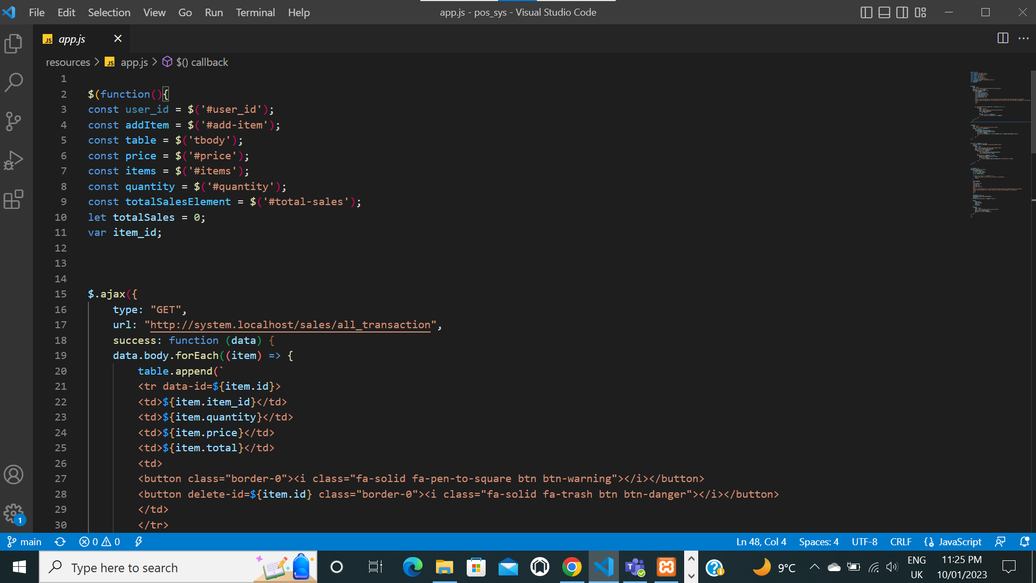

Figure (23): ajax get method

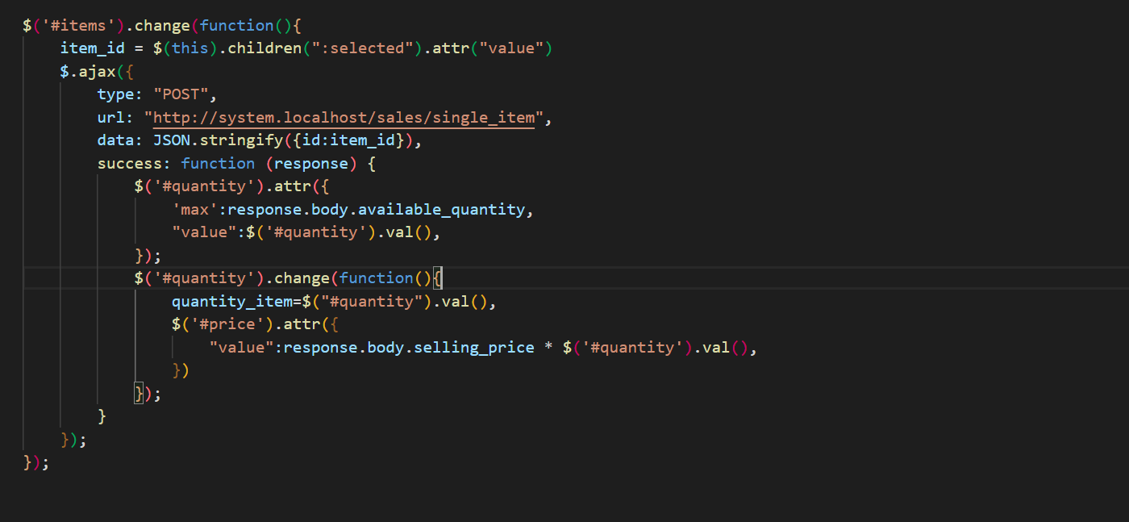

Figure (24): ajax post method

Figure (25): ajax delete method

**References**

https://www.w3schools.com/

<https://stackoverflow.com/>

https://www.php.net/

https://github.com

<https://www.diagrams.net/>

<https://www.youtube.com/>